47th Annual
Christmas Bazaar
December 10th, 2022

Name or Company Registration begins on
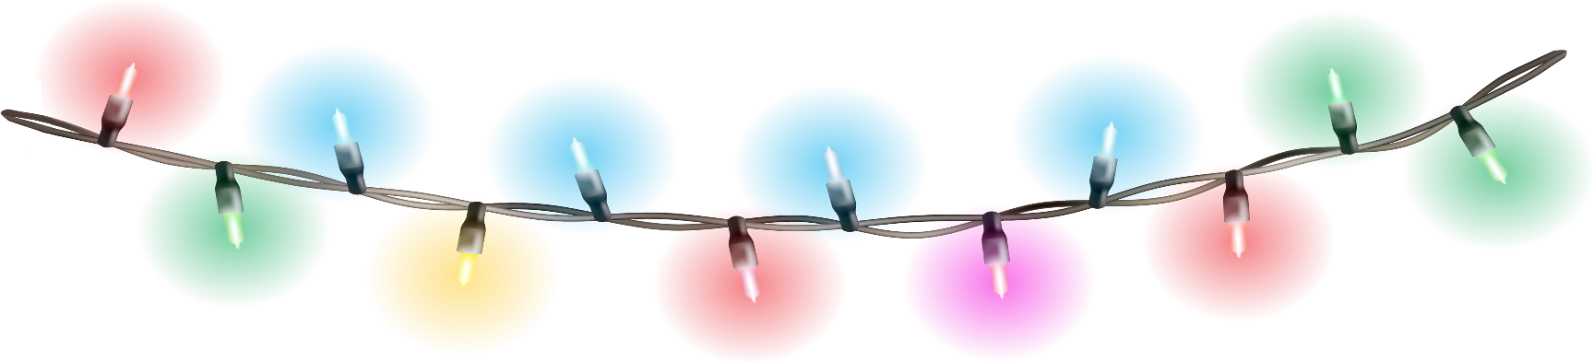
Mailing Address October 28th, 2022
Phone Number

Our building opens for set up at 8:00 AM
Sales end at 4:00PM
Clean up must be done by 6:00PM
If your space is not claimed by 10:00 AM it will be given to a different vendor.
Our chairs are limited. It is suggested that you bring your own comfy chairs.
Please post your food handler’s card when selling home made goods. The tribal sanitarian will be inspecting all food vendors. If needed please have a hand washing station. Please keep in mind that there will be no duplicated food stands and no propane in the building.
Please post your payment on your table

Do you need electricity? Yes / No
What will you be bringing to sell or trade?

The big bazaar is a fundraiser for the Warm Springs Recreation Department. The revenues are used to buy much needed equipment and supplies for all of our programs. We are very grateful. Thank you for your support for the youth of Warm Springs.

All fees non-refundable vendor
3 x 8 space registered before December 9th, 2022 = $15.00 x =
3 x 8 space registered after December 9th, 2022 = $25.00 x =
*** Limited to 4 spaces per vendor ***
Signature Date:
***** For office use only *****

Space amount Amount paid Receipt # Staff initials

